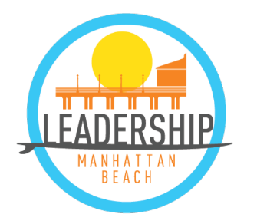
2021 - 2022
Day Date Time | Location | Topic
Wednesday Sep. 15 5:30-9:00 PM | TBD | Orientation
Saturday Sep. 18 8:30 AM  Sunday Sep. 19 4:30 PM | TBD | Leadership Retreat I:  Creating a Dynamic Team
Monday Sep. 27 5:30-8:00 PM | TBD | The Power of One: Civic Engagement
Monday Oct. 4 5:30-8:00 PM | TBD | Preserving Our Environment
Monday Oct. 18 5:30-8:00 PM | TBD | Business & Economics in the South Bay
Monday Nov. 1 5:30-8:00 PM | TBD | What’s Happening in Education?  First Project Discussion
Monday Nov. 15 5:00-8:00 PM | TBD | Meet the City  Prepare for Simulation
Monday Nov. 29 5:30-8:00 PM | TBD | Project Discussion & Selection
Monday Dec. 13 5:30-8:00 PM | TBD | City Council Simulation
Saturday Jan. 8 9:00-4:00 PM | TBD | Leadership Retreat II:  Maximizing Team Performance
Tuesday Jan. 18 5:30-8:00 PM | TBD | Kicking Off Our Project
Monday Jan. 31 5:30-8:00 PM | TBD | Ethics and Integrity
Monday Feb. 14 5:30-8:00 PM | TBD | Project Meeting/Team Building
Monday Feb. 28 5:30-8:00 PM | TBD | Project Meeting/Team Building
Monday Mar. 14 5:30-8:00 PM | TBD | Project Meeting/Team Building
Monday Mar. 28 5:30-8:00 PM | TBD | Project Meeting/Team Building
Monday Apr. 11 5:30-8:00 PM | TBD | Project Meeting/Team Building
Monday Apr. 25 5:30-8:00 PM | TBD | Project Meeting/Team Building
Monday May 9 5:30-8:00 PM | TBD | Final Session: Lessons Learned
Tuesday May 17 6:30 PM | TBD | Project Presentation to City Council
Friday May 20 6:00-9:00 PM | TBD | Graduation
“Developing and Uniting Community Leaders”

